Advanced Database Training
2026
Vaishnavi Kamthe

Assignment 4b

Question
Create an orders_data table using orders_data.csv file. This table contains the sales and orders data.
Create a table orders_over_time with following schema,
startday date
endday date
number_of_orders int
net_quantity int
total_sales float
average_selling_price float
average_order_value float
units_per_order float
timestamp timestamp
Create a stored procedure order_over_time_calculation which will take two arguments start_date and end_date. This procedure will insert the data in orders_over_time table.
Implementation of the procedure is as follows,
1. First it will delete the data from orders_over_time table where the startdate and enddate values are equal to the values passed in the procedure parameters.
2. After that it will query the data from orders_data table and will insert into the orders_over_time table for given start_date and end_date
orders_over_time table column calculations,
- startday = start_date (value passed in the procedure parameter)
- endday = end_date (value passed in the procedure parameter)
- number_of_orders = total orders from orders_data table in the given start_date and end_date
- net_quantity = total net_quantity from orders_data table in the given start_date and end_date
- total_sales = total total_sales from orders_data table in the given start_date and end_date
- average_selling_price = total_sales/net_quantity (round the result to 2 decimals)
- average_order_value = total_sales_without_returns/orders (round the result to 2 decimals)
- units_per_order = net_quantity/orders (round the result to 2 decimals)
- timestamp = current timestamp
Imported the CSV and Stored it in orders_data Table :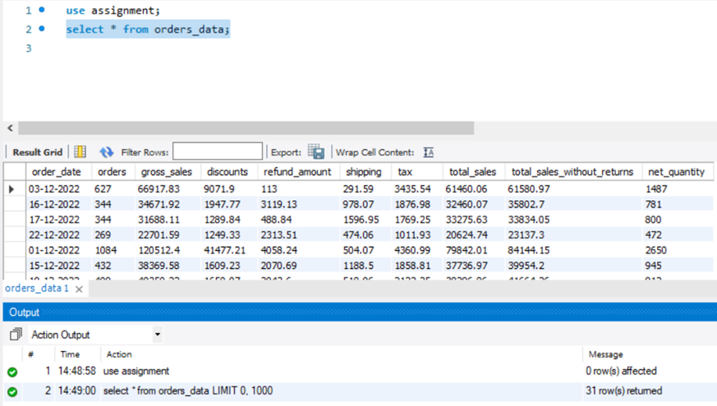
Created orders_over_time Table : 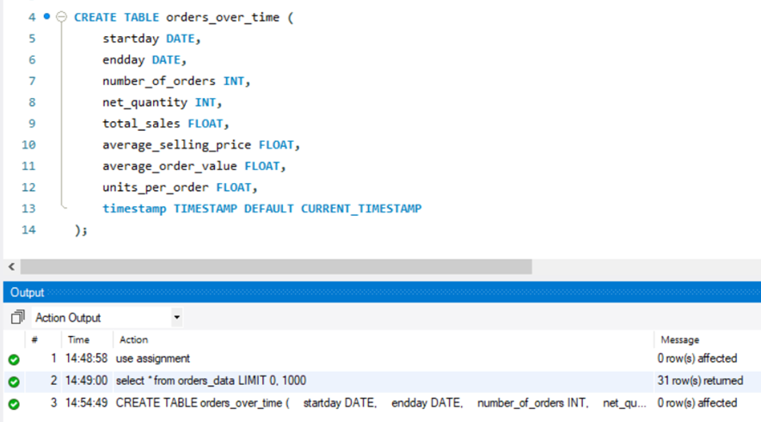
Created the order_over_time_calculation Procedure :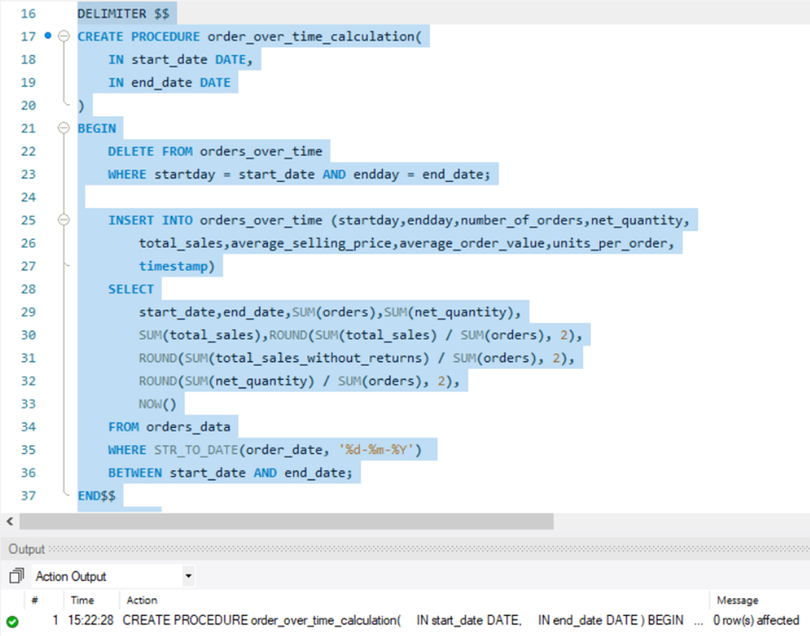
Testing the Procedure